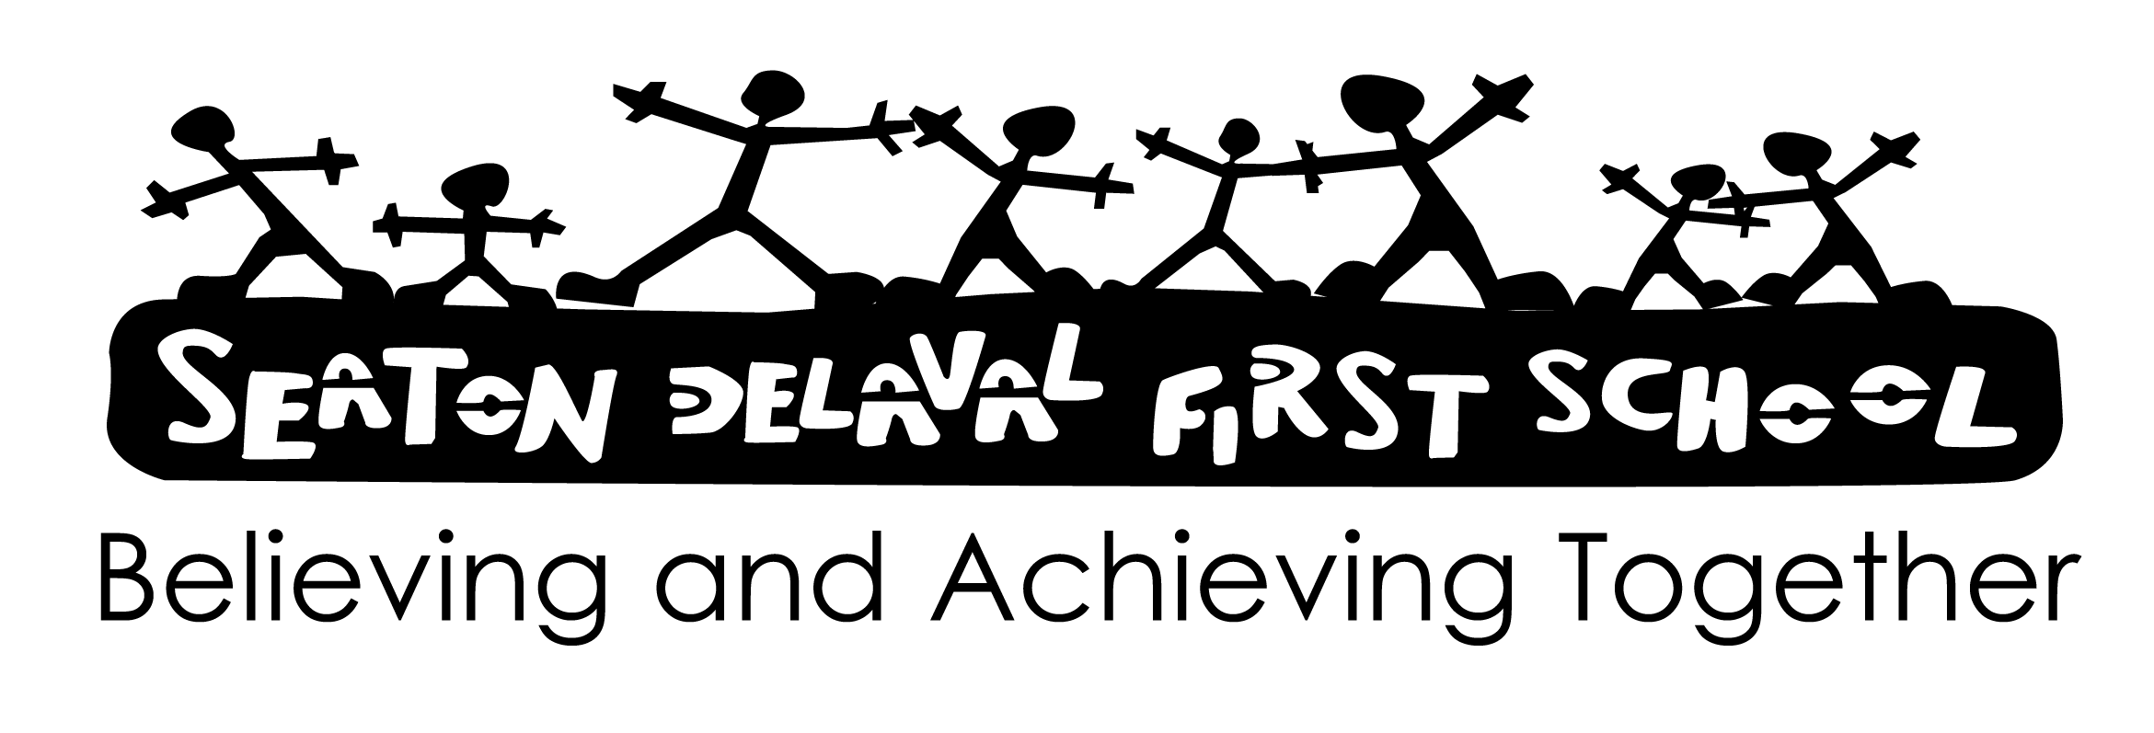

Here is another list of links for you to look at for work:

White Rose Maths are doing daily Maths lessons from Monday with resources – Homelearning White Rose Maths

Joe Wicks body coach – doing PE classes daily.

The Bodycoach.tv starts 9am Monday

